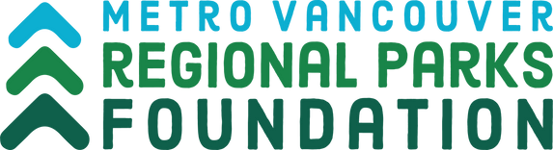
George Ross Legacy Stewardship Program

Application Form: Small Projects

The George Ross Legacy Stewardship Program is a funding program created to help support hands‐on citizen stewardship activities by park partners in Metro Vancouver Regional Parks and Regional Greenways. The program is funded by the interest from an endowment created from the generous $2.8 million bequest from Mr. George Ross, who loved trees and parks. This program is administered by Metro Vancouver Regional Parks Foundation, a non-profit society established to support and enhance Metro Vancouver’s Regional Parks system.
Complete the following application. Should you run out of space, include details on a separate sheet with pertinent subject heading.

A. General Information

Organization Name:
Mailing Address:
City:
Postal Code:
Phone:
Email Address:
Website URL:
Brief Description of Organization:

Primary Contact
First and last name:
Title/Position:
Mailing Address
City:
Postal Code:
Phone:
Email Address:
Telephone:

For Ad Hoc Groups

Main Applicant
First and last name:
Title/Position
Mailing Address
City:
Postal Code:
Phone:
Email Address:
Telephone:
19 years or older? (yes/no)

Co-Applicant
First and last name:
Title/Position
Mailing Address
City:
Postal Code:
Phone:
Email Address:
Telephone:
19 years or older? (yes/no)

B. Project Information
Project Title:
Total Amount Requested:
Metro Vancouver Regional Park or Regional Greenway which your project will take place:
Proposed Start Date (dd-mm-yy)

Proposed End Date (dd-mm-yy)

Do you have general liability insurance? (yes/no) Some projects may require this.

- Project Description:
- Project Objectives:
- How will this project benefit the Regional Park/Greenway? How will it contribute to the improvement of the region’s ecological health?

- Who will be the participants? (check all that apply)
Park visitors
Park neighbors
Families
Youth
Students
Seniors
New Canadians
Park Partner Groups

Approximately how many people will participate in your project?

- How will you acknowledge the contribution of MVRP Foundation and Metro Vancouver Regional Parks?

- Total budget for your project:

Description | Cost | Amount Requested
Total:

Email the application form to the Community Development Coordinator in your area.
West Area Contact East Area Contact Central Area Contact
Theresa Harding Jeff Rotin Trina Sakata
Theresa.Harding@metrovancouver.org Jeff.Rotin@metrovancouver.org Trina.Sakata@metrovancouver.org
Tel: 604.224.5739 Tel: 604.530.4983 Tel: 604.520.6442
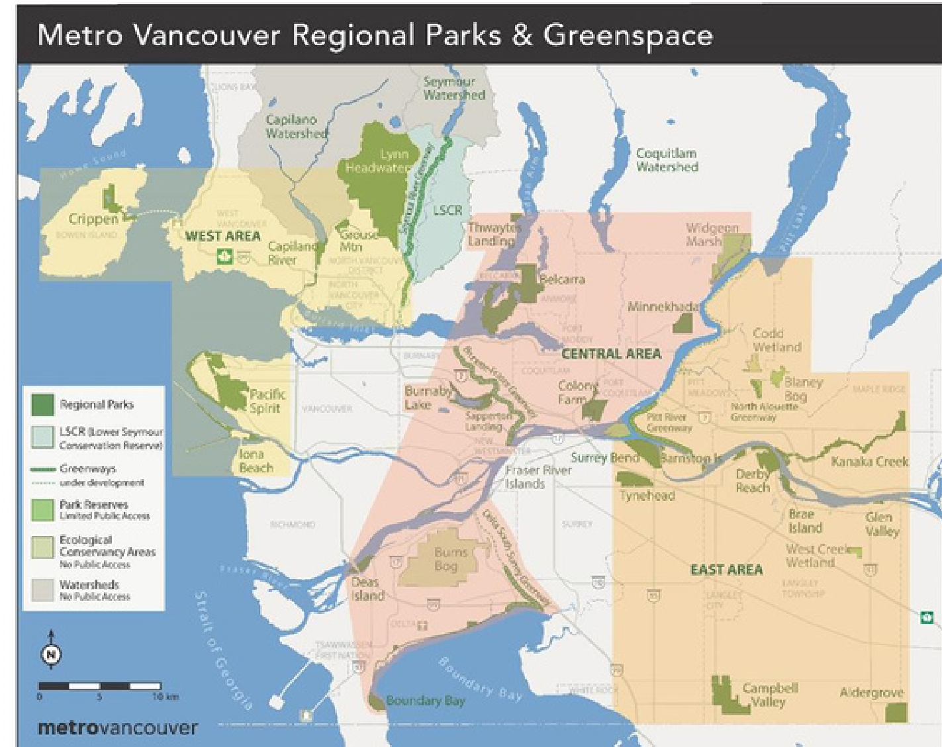

C. Certification
I hereby declare that the information in this application is accurate and complete.
Print Name of Person Authorized to Sign:
Date (dd-mm-yyyy):
Authorized Signature:

