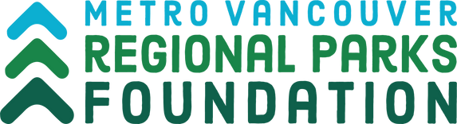
George Ross Legacy Stewardship Program
Final Report form: Medium & Large Projects
Please Complete this FINAL REPORT FORM with details of your organization and project.

A. General Information
Organization Name:
Project Title:
Regional park or greenway in which your project took place: Amount of project award:
Short summary of your project for media purposes:

B. Project Outcomes
Date project completed (dd-mm-yyyy):
Did you achieve your project goals and objectives? If not, explain why not:
How did you measure success of your project?
How were Metro Vancouver and MVRP Foundation acknowledged for their support?
Describe any challenges, if any, encountered throughout the project from beginning to completion, and how you addressed them:

C. Project Statistics
Number of Volunteers Involved:
Total volunteer hours:
If it was an event, # of people attended:
List partner groups and their specific roles in the project:
Items produced and materials distributed (where relevant):
Additional project support (I.e., gifts in kind or additional funding)

D. Stewardship Activity Statistics (where relevant)

Type of activity: ex: bird/bat/owl boxes, native planting, habitat maintenance, invasive species removal:

Species Removed:

Species Planted:

Weight of green waste removed:

Number of trees/shrubs planted:

Area (square meters) of habitat restored:

Number of bird/bat boxes installed:

E. Application Process
Describe any challenges, if any, encountered throughout the inquiry and application process:
Would you apply for a George Ross Legacy Stewardship Program project in the future? If not, why?

F. Additional Documentation
Please include any documentation from your project, such as:
- Photographs – e.g., before and after
- Provide photo credit for each photo
- Provide signed photo release forms for each photograph
- Videos
- Brochures, newsletters, flyers, website URL, press releases, etc. Media Clippings
Please use the space below for any additional comments that weren’t addressed elsewhere in this report template:

G. Final Expense Report
*For expenses covered by the George Ross Legacy Stewardship Program Funding:

Professional fees, contractor services (including honoraria), materials, supplies, plants, equipment rentals, other project costs.

Expenses Itemize Cost
(Provide receipts for each)

Email or mail final reports to:
Rachelle McBride rachelle@mvrpfoundation.ca
Metro Vancouver Regional Parks Foundation
6825 Cariboo Rd, Burnaby, BC V3N 4A3

G. Certification
I hereby declare that the information in this final report is accurate and complete. I also certify that this final report supports the project or initiative endorsed by the organization’s governing body.

Print Name of Person Authorized to Sign:

Date (dd-mm-yyyy):

Authorized Signature:

