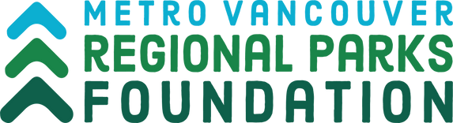
George Ross Legacy Stewardship Program
Final Report Form: Small Projects

Please Complete this FINAL REPORT FORM with details of your organization and project.

General Information

Organization Name:

Project Title:

Regional park or greenway in which your project took place:

Amount of project award:

Short summary of your project for media purposes:

B. Project Outcomes

Date project completed (dd-mm-yyyy):

Did you achieve your project goals and objectives? If not, explain why not

How did you measure success of your project?

How were Metro Vancouver and MVRP Foundation acknowledged for their support?

Describe any challenges, if any, encountered throughout the project from beginning to completion, and how you addressed them:

C. Additional Documentation
Please include any documentation from your project, such as:
Photographs – e.g., before and after
Provide photo credit for each photo
Provide signed photo release forms for each photograph
Videos
Brochures, newsletters, flyers, website URL, press releases, etc. Media Clippings

D. Final Expense Report
*For expenses covered by the George Ross Legacy Stewardship Program Funding:
Professional fees, contractor services (including honoraria), materials, supplies, plants, equipment rentals, other project costs.

Expenses Itemize Cost
(Provide receipts for each)

Email or mail final reports to:
Rachelle McBride rachelle@mvrpfoundation.ca
Metro Vancouver Regional Parks Foundation
6825 Cariboo Rd, Burnaby, BC V3N 4A3

E. Certification
I hereby declare that the information in this final report is accurate and complete. I also certify that this final report supports the project or initiative endorsed by the organization’s governing body.
Print Name of Person Authorized to Sign:

Date (dd-mm-yyyy):

Authorized Signature:

